CAPITOLO 1: Titolo
1.1. Impostazione della pagina
Una cartella (pagina) di Word comprende in media 30–32 righe per un totale di 2200–2300 battute, spazi esclusi (per sapere se si rientra in tali parametri, basta cliccare sul comando ‘Strumenti’ della barra relativa e poi su ‘Conteggio parole’).
L’impostazione dei margini deve tener conto del fatto che la rilegatura finale del lavoro, riducendo lo spazio non occupato dal testo, inciderà sulla resa visiva. Pertanto, si consiglia di adottare i seguenti parametri (cliccando su ‘Imposta pagina’ del comando ‘File’):
- Margine sinistro 3,5 cm
- Margine destro 2,5 cm
- Margini superiore e inferiore 2,5 cm
- Dimensioni e carattere:
  - Times New Roman 12 per il corpo del testo
  - Times New Roman 16 per il titolo del capitolo
  - Times New Roman 14 per il titolo del paragrafo
  - Times New Roman 12 per il titolo del sotto paragrafo
  - Times New Roman 12 e corsivo per il titolo del sotto sotto paragrafo
  - Times New Roman 10 per le note
  - Times New Roman 11 per citazioni indentate, esempi numerati, tabelle e didascalie
- L’allineamento del paragrafo dev’essere giustificato
- L’interlinea deve corrispondere a un valore di 1,5 cm per il testo. Le note, le tabelle, le citazioni indentate, gli esempi numerati e le didascalie devono avere interlinea 1
- I paragrafi devono avere una prima riga rientrante di 1 cm
- Il primo paragrafo di un capitolo, di un paragrafo, che segue una figura, una tabella, una citazione indentata o un esempio numerato non deve aver alcun rientro
- Le pagine vanno numerate a esclusione del frontespizio, della dedica e/o dei ringraziamenti e dell’indice.
1.2. Struttura consigliata per la Tesi/Prova finale:
1. FRONTESPIZIO
2. RINGRAZIAMENTI / DEDICA (eventuali)
3. INDICE
4. ABSTRAC
5. INTRODUZIONE
6. CORPO DEL TESTO (suddiviso in capitoli)
7. CONCLUSIONI
9. APPENDICI O ALLEGATI (opzionali)
9. BIBLIOGRAFIA
1.3. Norme editoriali per il testo, le note e la bibliografia
Per quanto lo stile del testo vanno evitati lo stile grassetto e la sottolineatura, mentre ci si può servire del corsivo se risponde a criteri di funzionalità.
1.3.1. Titolo sotto paragrafo
Vanno indicati in corsivo:

- i titoli delle opere (testi, dipinti, giornale);
- le parole straniere;
- le parole oggetto di analisi.

Per evidenziare una o più parole, si possono usare le virgolette singole: es. ‘tabloidizzazione’.
Le citazioni brevi (meno di tre righe di testo) vanno inserite nel corpo del teso fra “virgolette”.
Le citazioni più lunghe devono essere separate dal testo da una spaziatura prima e dopo e indentate di 1 cm; in questo caso non si usano le virgolette; l’interlinea per le citazioni lunghe (indentate) è singola.
1.3.1. Titolo sotto sotto paragrafo
Tutte le citazioni (lunghe e bravi) devono essere seguite dal riferimento alla fonte da cui sono tratte; il riferimento va indicato tra parentesi tonde (non in nota) con il cognome dell’autore o dell’autrice seguito dall’anno di pubblicazione e dalla pagina o dalle pagine, ad esempio (Venuti 2020: 15).
Il riferimento alla fonte bibliografica va inserito anche quando non si cita direttamente da un testo, ma si riassume il contenuto letto e rielaborato da una specifica fonte e incorporato nel proprio lavoro (Venuti 2020: 12-18).
Gli esempi devono essere numerati, essere separati dal testo da una spaziatura prima e dopo e con un rientro a sinistra di 1 cm.
Punti di sospensione: dopo i tre punti di sospensione il testo successivo è preceduto da uno spazio bianco. Per esempio: voglio… tre milioni; è troppo tardi… continueremo domani.
Punti di omissione: l’omissione di una porzione del testo in una citazione viene segnalata con tre punti tra parentesi quadre: […].
Il trattino breve (interposto tra due caratteri senza lasciare alcuno spazio) va usato come elemento di congiunzione nei termini composti [prêt-à-porter] e negli intervalli numerici [pp. 5-9].
Il trattino lungo (preceduto e seguito da uno spazio bianco) va usato come: a) elemento di separazione per indicare suddivisioni all’interno di elementi quali titoli, didascalie e diciture di vario genere [Punk a Londra – King’s Road, 1980]; b) elemento di apertura e di chiusura di un inciso all’interno del testo.
I numeri, escluse le date, vanno scritti per esteso. Per le date si considerino però queste eccezioni: non anni ’50, bensì anni Cinquanta; non ’800, bensì Ottocento. Per il 1848 si può usare Quarantotto e per il 1968 si può usare Sessantotto. Infine non nel ’29, bensì nel 1929.

TITOLO CAPITOLO 2
2.1. Introduction
Corpus linguistics involves the analysis of large collections of computerized texts, often carefully sampled in order to be representative of a particular language variety (McEnery and Wilson 1996, Kennedy 1998, Hunston 2002). Such texts (known as corpora) are usually subjected to quantitative forms of analysis via software which can identify frequent linguistic patterns. Corpus software can also identify frequent non-fixed combinations of words (collocations) and distinctive words, called ‘keywords’ by conducting comparisons between multiple corpora. Such patterns can be automatically identified via a naive or corpus-driven approach – the analyst does not know what will be found in the corpus and starts with no hypotheses, but instead frequent or salient patterns become the focus of the analysis once they are uncovered.
In the past, a small number of studies have used corpus methods, combined with a variationist approach to sociolinguistics in order to investigate differences between male and female speech. For example, Rayson et al. (1997) used 4.2 million words of transcribed speech from the spoken demographic section (consisting of private conversations) of the British National Corpus (BNC), using chi-squared tests to identify which words were distinctive of male and female speech.
2.2. Method
For the purposes of this study, four corpora were utilised. All corpora were of equal sizes (a million words) and followed the same sampling framework, containing 500 samples of texts (each approximately 2,000 words in size) from four main categories (press, general prose, learned writing and fiction) of published writing in British English, further subdivided into 15 subcategories (romantic fiction, science fiction etc.).
Figures 1 and 2 show the frequencies at the four sampling points for male and female pronoun usage, while Figure 3 gives a direct comparison between all male and female pronouns. While the figures show lines in order for trends to be more easily seen, it should be noted that the lines themselves are projections of trends – there is only actual data for four sampling points (1931, 1961, 1991 and 2006).
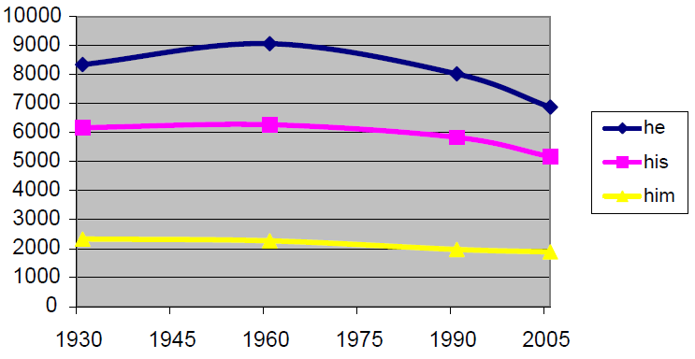
Figure 1. Frequency of male pronouns
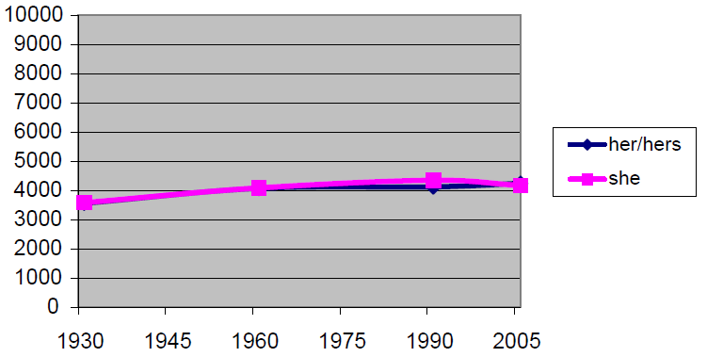
Figure 2. Frequency of female pronouns
It can be seen that there have been decreases in usage of all male pronouns (at least since 1961), although this is most marked for the most frequent pronoun he. Female pronouns seem to show a slight increase, although this seems to be tailing off in the more recent data. The gap between male and female pronouns still exists and is substantial, but it appears to be shrinking. The data for female pronouns does not show a single clear pattern however. While her/hers shows a slight increase, she has actually appeared to decrease between the last two sampling points. When looking at other types of pronouns such as I, you and they (not shown as figures), it was found that in general there had been increases in first and second person pronouns over time, which is perhaps reflective of written English becoming more conversational and personalised in recent years (see Fairclough 1989, 1994). This may therefore relate to the slight decline in she and the male pronouns.

 | BLOB | LOB | FLOB | BE06
Him or her | 0 | 4 | 5 | 3
He or she | 4 | 5 | 14 | 7
he/she | 0 | 0 | 2 | 3
s/he | 0 | 0 | 8 | 1
him/her | 0 | 0 | 3 | 0
totals | 4 | 9 | 32 | 14
Table 1: Frequencies of gender inclusive pronouns
Another aspect of pronouns involves the use of terms which attempt to be inclusive by presenting both alternatives, such as him/her or he or she. Table 1 gives the frequencies of these terms and similar ones. Apart from s/he which may be argued to place (part of) the female pronoun first, in general, there were no terms in any of the corpora which put the female pronoun first such as she or he.
2.3. Analysis
To analyse the phenomenon of speaker opinion – variously known as evaluation, appraisal and stance within linguistics – a new framework of evaluation is introduced as an alternative to and a synthesis of existing approaches. As a springboard for this framework I take Thompson and Hunston’s definition of evaluation as
the broad cover term for the expression of the speaker’s or writer’s attitude or stance towards, viewpoint on, or feelings about the entities or propositions that he or she is talking about. […] That attitude may relate to certainty or obligation or desirability or any of a number of other sets of values. (Thompson and Hunston 2000: 5)
Thus, Scheibman mentions a kind of “interactive, or empathetic, subjectivity on the part of the speaker towards the addressee” (Scheibman 2001: 85), in that speakers express a subjective construal of hearers’ agentivity and personalize their utterances in relation to hearers.
Some evaluations of comprehensibility are in fact evaluations in terms of style and comment on a news actor’s language activity (in a broad sense), as in the following examples:
1. More ambiguously, the Conservative trade spokesman, Tim Yeo, remarked that: ‘The manner of his delivery shows how much progress he personally has made since last year.’ (The Guardian, 10 June 2010)
2. The chief executives of four of Britain’s biggest banks yesterday received a mauling from MPs over the charges and complex terms they impose on customers through credit cards. (The Independent, 4 August 2008)
Thus, Scheibman mentions a kind of “interactive, or empathetic, subjectivity on the part of the speaker towards the addressee” (Scheibman 2001: 85), in that speakers express a subjective construal of hearers’ agentivity and personalize their utterances in relation to hearers.
2.3.1 Analysis
Thus, Scheibman mentions a kind of “interactive, or empathetic, subjectivity on the part of the speaker towards the addressee” (Scheibman 2001: 85), in that speakers express a subjective construal of hearers’ agentivity and personalize their utterances in relation to hearers.
Thus, Scheibman mentions a kind of “interactive, or empathetic, subjectivity on the part of the speaker towards the addressee” (Scheibman 2001: 85), in that speakers express a subjective construal of hearers’ agentivity and personalize their utterances in relation to hearers.

References
Fairclough, N. (1992) Discourse and Social Change. Cambridge: Polity Press.
Fairclough, N. (1994) Conversationalization of public discourse and the authority of the consumer. In Russell Keat, Nigel Whiteley and Nicholas Abercombie (eds) The Authority of the Consumer. London: Routledge, 253–268.
Harrington, K., Litosseliti, L., Sauntson, H. and Sunderland, J. (eds) (2008) Gender and Language Research Methodologies. London: Palgrave Macmillan.
Hunston, S. (2002) Corpora in Applied Linguistics. Cambridge: Cambridge University Press.
Kennedy, G. (1998) An Introduction to Corpus Linguistics. London: Longman.
McEnery, T. and Wilson, A. (1996) Corpus Linguistics. Edinburgh: Edinburgh University Press.
Oakes, M. (2009) Corpus linguistics and language variation. In P. Baker (ed.) Contemporary Approaches to Corpus Linguistics. London: Continuum, 159–183.
Pauwels, A. (2003) Linguistic sexism and feminist linguistic activism. In J. Holmes and M. Meyerhoff (eds) The Handbook of Language and Gender. Oxford: Blackwell, 550–572.
Rayson, P., Leech, G. and Hodges, M. (1997) Social differentiation in the use of English vocabulary: Some analyses of the conversational component of the British National Corpus. International Journal of Corpus Linguistics 2 (1): 133–152.
Scheibman, J. (2001) Local patterns of subjectivity in person and verb type in American English conversation. In J. L. Bybee and P. Hopper (eds), Frequency and the Emergence of Linguistic Structure. Amsterdam: John Benjamins, 61–89.
Schwarz, J. (2006) ‘Non-sexist Language’ at the Beginning of the 21st Century: Interpretative Repertoires and Evaluation in the Metalinguistic Accounts of Focus Group Participants Representing Differences in Age and Academic Discipline. PhD thesis. Lancaster University.
Thompson, G. and S. Hunston (2000) Evaluation: an introduction. In Hunston, S. and G. Thompson (eds) Evaluation in Text. Authorial Stance and the Construction of Discourse. Oxford: Oxford University Press, 1–27.

